**Gantt**

Identify need and benefits (Week 1)

Meet with the customers (Week 1)

Establish Use Cases

List requirements

Design Documents

Define database

Define SPMP

Define the functionality of the game

Define the student-expert interaction

Revise definitions/documents as required

Research possible website URL

Research website templates

Research website host

**Milestone: Establish project details**

Establish website URL

Establish website template

Establish website host

Research possible account system API/plugin

Contact account system API/plugin

Research possible payment processor

Contact payment processor

Research possible chat API/plugin

Contact chat API/plugin

**Milestone: Find all APIs**

Establish connection with payment processor

Implement payment processor

Establish Connection to the chat API/plugin

Implement chat API/plugin

Establish connection with account system API/plugin

Implement account system API/plugin

**Milestone: Connect all APIs to website**

Test APIs/plugins

Revise APIs/plugins where necessary

Test Payment processor

**Milestone: Finish API and website interactions**

implementing the functionality of the articles

Define desired output/control/input (OCI)

Find a template to use

Establish role capabilities

Implement roles

Test roles

Revise roles as needed

**Milestone: Finish roles**

Ensure all implementations work together

Finish designing the website

**Milestone: Finish rough draft of project**

Test Project

Revise project where necessary

**Milestone: Finish project revision**

Test changes

Revise changes where necessary

**Milestone: Deploy project**

**Maintenance: maintain project**

**WBS**

**SPMP parts:**

**1.1 Project Overview**

Executive summary: description of project, product summary

The goal of this project is to develop a website for older gamers to use to learn more about the game. In this website, we will develop a interactive chat, a way to search for specific articles, a way for users to interact with each other, and a way for admin to check on the users roles. This website will be free but have ads and a donation button.

**1.2 Project Deliverables**

All items to be delivered, including delivery dates and location

All pre-project deliverables will be due at the end of March. The entire project will be due April 24, 2021.

**1.3 Evolution of the SPMP**

Plans for anticipated and unanticipated change

In the event of an anticipated or unanticipated change, I will redesign as soon as possible in order to alter the website in accordance with the new changes.

**1.4 Reference Materials**

Complete list of materials referenced in SPMP (subject to change)

<https://clickhelp.com/software-documentation-glossary/documentation-plan/>

<https://jeopardylabs.com/embed/?jeopardy_id=23182675>

**1.5 Definitions and Acronyms**

Moderator – A registered user picked by a admin who has the ability to delete comments and ban users

Writer – A registered user picked by an admin who has all abilities of a moderator and the ability to write and edit articles.

Admin – A registered user in charge of managing roles throughout the website.

**2.2 Organizational Structure**

Internal management, organization chart

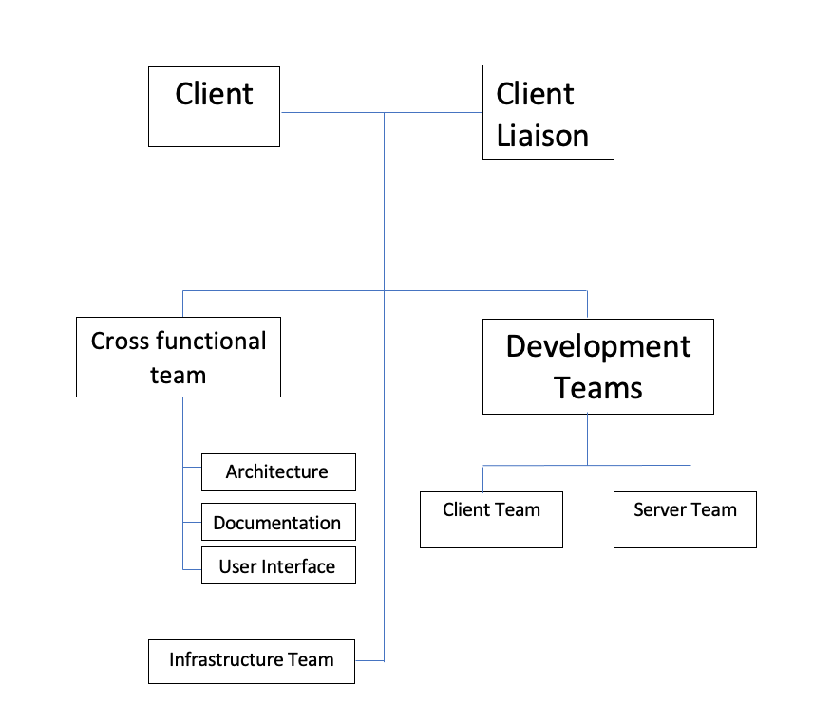

**2.3 Organizational Interfaces**

Relations with other entities (subcontractors, commercial software)

Since I require an API for the account system, ability to chat, and payment processor (not all of these will be APIs), I must develop a working relationship with the owner of these APIs.

**2.4 Project Responsibilities**

Major functions and activities; nature of each; who is in charge

Matrix of project functions/activities vs responsible individuals

The staff will consist of only 1 person, which will create the project. I will also be the client liaison.

**3.1 Management Objectives and Priorities**

Describes management philosophy, priorities among requirements, schedule, and budget

The priority requirements are the account system, the payment processor, and the chat. The budget is undefined, but as low as possible and certainly below $50. My management philosophy is only my best judgment.

**3.2 Assumptions, Dependencies and Constraints**

External events the project depends on, constraints under which the project is to be conducted.

Take account of any possible errors or difficulties. Any systems the program will rely on, i.e., the different APIs needed

The project depends on getting working APIs for the account system, chat, and payment processors. In addition, the schedule of the project is subject to change based upon the client’s desires. Furthermore, I must provide all functionality without ever leaving the domain.

**3.3 Risk Management**

Identification and assessment of risk factors, mechanism for tracking risks, implementation of contingency plans

1. Project too large: If the project is too large, I will identify areas of the website that can be eliminated then discuss with the client.
2. Project too complex: If the project is too large, I will identify requirements that can be eliminated then discuss with the client.
3. Leaving class: If I leave, I will tell the client.
4. Client dislikes project: If the client is unhappy with my project, we will attempt to fix the website based upon their preferences.

**3.5 Monitoring and Controlling Mechanisms**

Frequency and mechanisms for reporting

I will report project progress once per week regularly. I will report each time I encounter a serious problem or finish a part of the project and see help if needed. All reporting will be done through Github.

**3.4 Staffing Plan**

Numbers and types of personnel required to conduct the project

The staff will consist of only one person, which specializes in programming. I will also need to be the client liaison.

**4.1 Methods, Tools and Techniques**

Specify the methods, tools, and techniques to be used on the project

For my project I will utilize the Waterfall Method.

Step:

1. Feasibility study
2. Requirements
3. Design
4. Implementation
5. Testing
6. Installation a.k.a. Deployment
7. Maintenance

**4.2 Software Documentation**

Describe the documentation plan

1. Project Name: paradox explorer (work in progress)
2. Scope and Objectives: Design a interactive website that teaches users about the given game.
3. Detailed Content Plan: The website will include a method for registered users to talk on each article, a way for admin to check on registered user roles, and a way for users to support the website. The website will be free to create an account for the website.
4. Time Estimates: A basic setup of the website should be completed early April in 2021 and the entire project will be finished by April 24, 2021.
5. Responsible Persons: The responsible persons are me alone developing the website.
6. Workflow: I will have hard deadlines and a schedule of when certain tasks will be completed as well as assigning time frames to those tasks.
7. Resources (software, style guides, websites): The website will use an self-built role management system. In addition, the website will use APIs/plugins for the account system, chat, and payment processor.
8. Publishing Details (formats, ways of delivery to end users): I will use GitHub and GitHub actions.

**4.3 Project Support Functions**

Plans for (at least) the following project support functions.

Plan to ensure quality assurance - evaluates and modifies an organization's procedures to make sure they provide the desired results. A quality assurance plan should include an organizational structure, details on each employee's responsibilities, and the qualifications an employee needs to fulfill those responsibilities.

Configuration management plan (IEEE Std 1042)- the management of software engineering projects.

Verification and validation plan - to identify the activities that will establish compliance with the requirements (**verification**) and to establish that the system will meet the customers' expectations (**validation**).

**5.1 Work Breakdown Structure (WBS)**

Hierarchical decomposition of project into activities and tasks

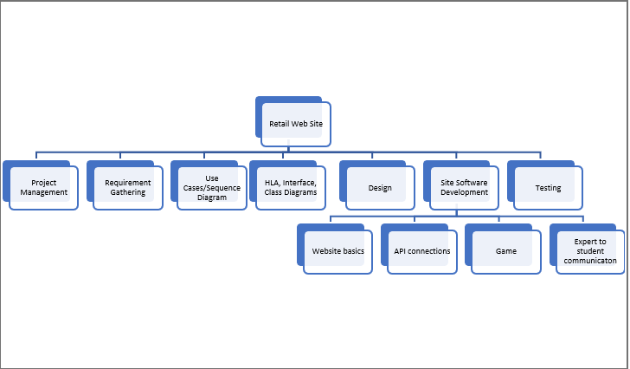

Full Gantt chart on GitHub.